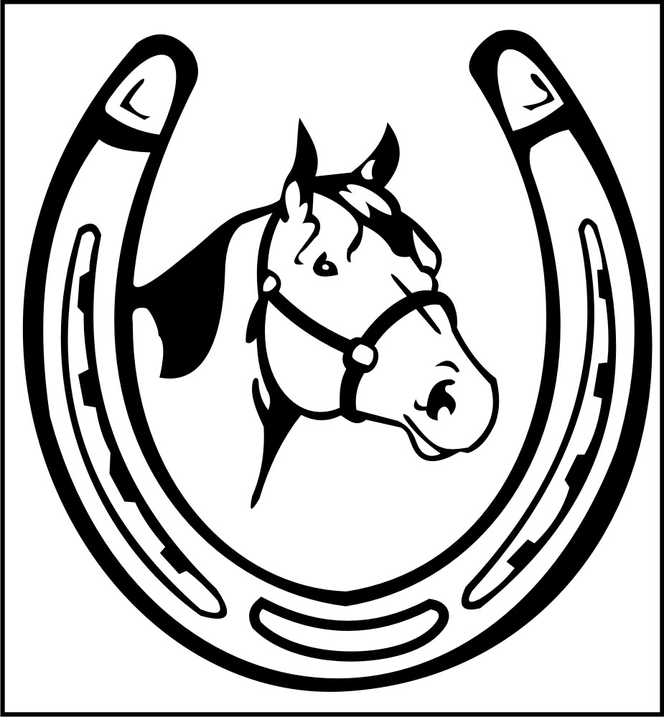
BOLERO HORSESHOE TURN
by Harold & Meredith Sears
(DRDC Nov 2012)

The Horseshoe Turn is a phase V figure. It takes two measures, dances SQQ; SQQ; and as a couple turns 1/2. It begins with a New Yorker–like action and ends with a sort of Underarm Turn that changes sides. If the man begins facing COH, the initial action will move toward LOD and he will end facing wall. If he begins facing wall, the initial action will move toward RLOD and he will end facing COH.

So, in a facing position, man facing COH, usually with lead hands joined, step side and forward R with right-side stretch producing a little left sway (lady side and fwd L with left-side stretch producing right sway) to a "V" position opening toward LOD. Step thru L a small step (lady thru R) with a checking action, like a New Yorker, and continuing to shape toward partner.

Let's pause in our description a moment: We often find ourselves comparing a checked through step to the familiar New Yorker, but this step is not completely "like a New Yorker." Where the New Yorker thru step is often placed well ahead in a relatively enthusiastic lunge and with bodies opened out to a fully side-by-side left-open position, what you might prefer here is a more subtle slipping of the lead feet through to a soft check, rather than a completely lowered lunge. Second, don't open fully away from your partner. Bolero is one of the many "dances of love." So stay shaped toward partner. Stay in that V-position of the first step. Step through with crossed thighs, not forward in left-open position. You might even continue to use your left sway (W right sway) to keep your upper bodies closer. As you will see, you can make this whole figure a close and cozy sequence.

On the third step of the first measure, the man recovers R (lady L) and raises lead hands, anticipating the lady's underarm turn to come. In the second measure, both step forward, the man beginning a tight left-face (LF) turn and the lady beginning a tighter RF underarm turn. The man finishes with a fwd R turning, and fwd L turning to face partner (lady fwd L turning under joined lead hands, fwd R to face). This part too can be gentle and cozy. Men, you are gazing at all sides of her as she turns under. Ladies, glance over your shoulder as he circles around you.

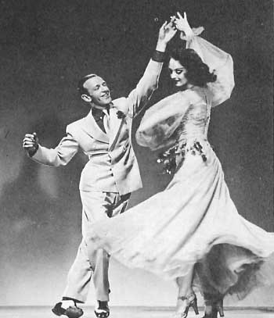
Perhaps the most troublesome step is the fourth step. If we begin with the man facing COH and do our cozy "New Yorker" action toward LOD, then step 4 for the man is forward toward LOD. For both of us, the underarm part of this figure consists of 3 forward steps curving. Knowing that a fairly sharp turn is coming up, the man might be tempted to step forward toward DLW or even toward COH. This can crowd the lady badly. Maybe worse is to make step 4 a back or a side step, like a switch to face partner. We are rushing into this turn, and there is no need to rush. We have three steps in which to make the turn, and we should use them. After the recover step of the first measure, calmly step forward again and only begin your LF turn (lady RF). The lady is making a tighter turn, so she will take this initial step DLW or even toward wall, but she too is stepping forward, not side. You might curve only 1/8 on this step. Then forward turn a little more, and finally forward and turn to face. This should be a smooth horseshoe-shaped path with no sharp angles.

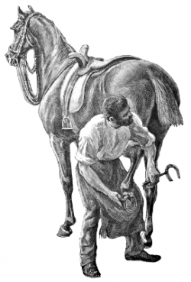
Another detail we might consider is the arm work during the first measure. Many dancers bring the lead arms through during the first Quick and then pull them back during the second Q, just as in a standard New Yorker, and then up for the underarm turn -- three separate actions -- it might feel a little more busy than you really want it to be. A quieter option is to leave the lead arms back in their butterfly-like position during the break (the first Q). The first measure becomes more Fence Line–like than New Yorker–like, and then it is a much smaller and calmer action to raise those arms to begin the underarm turn.

