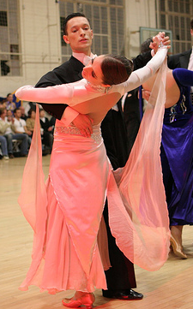

Check, Checking, Contra Check
by Harold & Meredith Sears

A Check is a step in which we stop and prepare to change direction. Checking is not a step, but is the process of stopping and preparing to change direction. A Contra Check is a check forward with contra-body action.

So, a Check is a step. In two step, we might be in closed position facing line of dance with lead feet free, and the cuer might say, "Forward to Banjo, Check, Fishtail." Actually, this little sequence is a bit contentious because we're not really stopping and going the other way. We don't "check" toward line and then dance to reverse. But a Check doesn't demand that we literally reverse directions. In this sequence, we usually Check toward line and center and then dance the first step of the Fishtail toward line and wall. This is a 1/4 change in stepping direction and fully enough to warrant the cue Check, as a preliminary heads-up.

In foxtrot, we might be in closed position facing line of dance with trail feet free, and the cuer might say, "Curved Feather Checking." Here, we step forward curving to the right, forward blending to banjo, and forward toward reverse and wall, and here we stop, ready to dance in another direction. Notice that we only danced the three steps of the Curved Feather. The cue Checking did not ask us to take another step. It simply asked us to rein in our momentum and prepare to step not forward but somewhere else.

Check and Checking are relatively straightforward, utilitarian cues. Take a step or don't but center your weight and get your balance under control. You're not going to keep going the way you were. But the Contra Check is a whole figure unto itself. It is a picture figure, a rich performance. It is a checking step, but not just a checking step.

In waltz, we might be in closed position with lead feet free. The man lowers into his right knee (woman left), begins a little left-face rotation in the hips and shoulders, and slides his left foot forward. His left foot moves forward as his right side is leading. This is the contra-body action. Actually, it is the lowering that causes the body rotation. Try it, men. Stand on your right foot and lower. You can do it with no rotation, but it feels like squatting. Allow the rotation and it feels graceful and elegant. Certainly don't force the rotation as though you were steering a big truck strongly left.
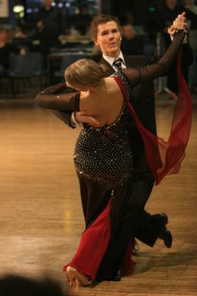
Of course, while the man is lowering and stepping forward left, the woman is lowering and stepping back right, but she is not stepping independently of the man. She is only allowing her right toe to slip across the floor. In contact from the lower torso down to the thighs, the man is slipping his right leg in under her body. Only when she feels the man stop and begin to change weight, will she stop that slipping foot movement and take weight herself. She must wait. If the man doesn’t provide the gentle pressure, if the woman doesn’t wait, receive, and respond to that pressure, then you can separate from each other, or he’ll step on her toes or push her over—it'll be a mess. If you do communicate through this direct contact, then you'll stay together, and there'll be no surprises.

The left-face rotation causes the man to turn his left foot out. If he is facing line and wall, his toes will be pointing toward line. This angled foot placement helps a great deal in maintaining balance. The woman steps straight back right, but her upper-body rotation causes her left foot to angle out and may turn her right foot a bit in. All four feet end up pretty much in one straight row (her R, his L, her L, his R—in a row), but the foot angles and the body contact help maintain balance. Hips are in. Toplines are well apart—you are stepping forward, but don't lean forward. Take weight but keep pressure on the man's right toe. If he takes full weight, she will rock back on her right heel. You both want to feel centered. Heads are left.

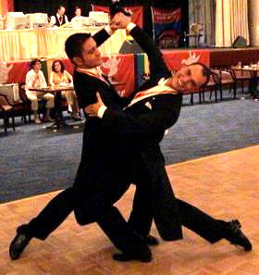
There are two more things that the man can think about to make this figure more comfortable for the woman. First, he can relax his right arm, slide his hand down toward the small of her back, and let her go. If he keeps his hand on her shoulder blade and his arm flexed, she will not be able to arch back and rotate left as freely. Second, he can rotate his whole frame left, which means his left arm will come back. We don't want to pull the left hand back separately, in a broken-chicken-wing effect. Maintain the same relationship between the left arm and the shoulders as usual, but rotate the whole assemblage. If he rotates his torso but leaves his left arm and hand forward, it will push on the woman and again interfere with her rotation and contra action.

To step forward checking is not a Contra Check. To sort-of lunge or leap forward, landing with a plop, even with right-shoulder lead, is not a Contra Check. The Contra Check is a soft lowering and sliding forward, with a little twist and urn-like flowing body lines.

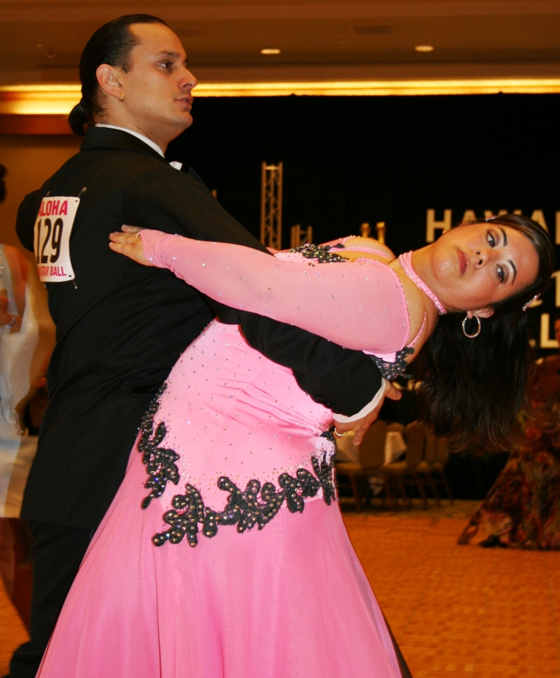
From Annette:

Richard Lamberty’s opinion on the Contra Check:

Richard does not believe that all 4 feet should be aligned at the end. He says that this styling is old fashioned and that, since then, the ballroom technique has evolved; the concept of stepping forward or back exactly in front or behind the supporting foot has given place to another principle: the left foot steps to the left, the right foot steps to the right, with space between the legs. This gives partners a lot more balance and comfort.

