Dance Right Through Her
by Harold and Meredith Sears
Sometimes, we men are just too polite. We don’t want to seem forward or pushy. We do want to be gentle and to give our partners their space. But such diffidence can lead us astray. For instance, in dancing the Foxtrot Reverse Turn or Open Telemark, we need to forge ahead and dance right through her.
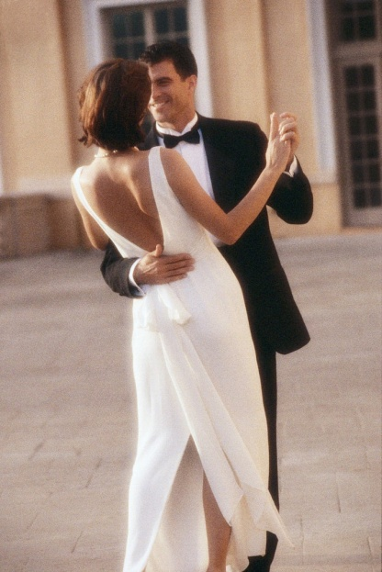
For a Reverse Turn, we might begin in closed position facing diagonal line and center. The man steps forward on his left foot with right-side lead. Of course the woman steps back right. The woman draws her left foot to her right and puts her heels together as the man pivots on his left and steps to the side past her Heel Turn, maintaining connection at the hips but letting the top line grow and separate. Opening the top line creates a little more centrifugal force to get you around. The man has led her Heel Turn by lowering, leading with the hips, stepping through her with right side lead, and by stepping across the line of dance. She rotates on her right heel and gradually changes weight by beat 3. The man’s third step is back left to closed position facing reverse. Finish a Full Reverse Turn with a step back right turning left, side and forward left, and forward right to Contra Banjo facing line and wall (sqq; sqq).
The common error is for the man to dance down the line of dance and to think that he has to dance "around" his lady. If you do this, she will be led to progress, will not be able to do the Heel Turn, and you will end in Banjo at the end of the first measure instead of Closed. Instead, take your first two steps directly toward diagonal line and center, turning your body as you move through her left side. Dance a straight line, not a curved path around her.
The secret to a clean Open Telemark is much the same. Begin in closed position facing diagonal line and center. Step forward left. The woman steps back right, draws left to right and puts her heels together as the man pivots on his left and steps side and back across the line of dance to face diagonal reverse and wall. She rotates on her right heel and changes weight. Ideally, the man and woman have precisely changed places by the end of beat 3, so the amount of turn is actually a little more than in a Reverse Turn Half. On beat 4, simply use a little right side stretch to open to semi-closed position, and step side and forward on the lead feet toward diagonal line and wall.
It may seem a bit inelegant to push through your partner as through a revolving door, but with good right-side lead and a firm step into her left side, you can make tight turns smoothly and comfortably—even a Double Reverse Spin. Just go through, not around.

