
Helper Cues
by Harold & Meredith Sears

Do you like "helper" cues? You might think that cueing is simply a matter of naming the figures we are to dance, in order, and ahead of the beat on which we are to step. But cuers usually try to go beyond the figure names. They add information about what position you should be in, which direction you should be facing, little modifications that would make one figure flow better into the next, even some of the specific steps that make up the figure. Do you appreciate this help?

Facing Direction —

Let's suppose we're dancing a two step. We dance a Box and then Two Turning Two Steps, and then the cuer says, "face the wall for a Broken Box." Later in this same dance, we hear, "Face to Face turn away; Back to Back turn to face." One dancer might think, a little impatiently: of course a Back to Back ends with a turn to face. The cuer didn't need to tell me that. Another dancer might appreciate the reminder. If you are dancing a waltz and the cuer says, "Telemark to Semi, diagonal line and wall," does the added directional information make you feel a little more secure?

Dance Position —

In a foxtrot, we might be dancing a Reverse Turn, and the cuer could add, "end in banjo." Or, "In and Out Runs, end in semi." These are the standard endings for these figures, so should they be a part of the cues?

Components —

In rumba, a Cross Body is a two-measure figure where you dance a Half Basic and then you move the woman across, perhaps from the outside of the circle to the inside, or visa versa. On the floor, you might hear "Cross Body," or you might hear "Half Basic to a Cross Body face center." The standard figure is two measures, but breaking it down does guide you a little more and forces you to remember a little less.

Steps —

In another waltz, we begin with a "Waltz Away and Together;; forward to a Half Box." Again, one dancer will know full well that a waltz Box starts with a forward step, and another will be saved from dancing the side step first.
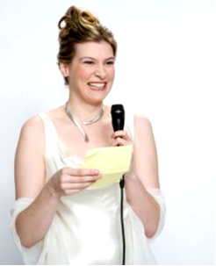
Modifications —

If a figure is modified by the choreographer, then we have to hear about it: "Spin Turn overturned to reverse and wall." We have to hear about the overturning in order to do the Feather Finish or whatever. But what if the figures are standard, yet a small modification would ease the flow?

In slow two step, we might dance a Basic picking up to a;; Left Turn With Inside Roll; or a Basic maneuvering to a;; Right Turn With Outside Roll. Surely you've heard this pattern. Do you appreciate the extra cue ("picking up," "maneuvering")? It's important in these examples to distinguish between a Maneuver (3 steps), which the cuer certainly does not want you to do, and maneuvering, which is not capitalized, not a figure, just an action — men, begin to turn in front of her as you complete the previous figure. So, a cuer could be very minimal and say, Basic;; Right Turn with Outside Roll; or he could help more.

Each of these helps constitutes a trade-off. With concise, minimal cues, we get to hear more of the music and perhaps feel like we are dancing more to the music. With richer cues, there is sometimes much more talking, covering up that music, but we are guided more carefully through the choreography. Maybe we'll stumble less.
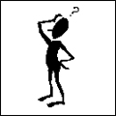
To —

A good compromise to many of these helper cues is strong and regular use of the word "to." Many teachers teach that word and use it faithfully whenever the dancer must prepare at the end of one figure, in order to dance the next figure properly. "To" helps to stack the cues so the dancer has time to think about the preparation required, and that little word can tell the dancer, loudly and plainly, to do it—to prepare, to do something different at the end of the previous figure than he usually does. If the dancers know the figures, then they know what preparation will be required. Turn a little, open out a little—these details don't have to be specified.

How about a rumba Half Basic to an Aida or Half Basic to a Whip? We hear the to, it focuses us on the next figure, and we know to open out just a little and so flow into that next figure more smoothly. We don't have to be told, Half Basic open to semi and thru to an Aida.

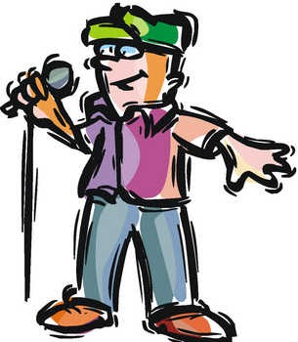
In a Half Basic to a Full Natural Top, that one very small syllable, tells the dancer to begin to turn right at the end of the Half Basic, to begin to flow into the Natural Top. It takes the place of longer helper cues such as maneuvering to a Natural Top or turning right to …. We get a little help and we can enjoy the music.

How about Alemana to a Lariat? No more than the word to tells us modify the Alemana just a little, to get her over toward the man's right side, ready to Lariat around. Or Alemana to a Ropespin? If we have been trained well to hear the word to, then it tells us to do something different at the end of the Alemana, this time to do the spiral of the Ropespin. Helpful cuers might say instead, "Alemana spiraling to a Ropespin." Aside from the extra syllables covering up the music, we are left with a small question about just how many spirals are called for—the one cued and the one of the Ropespin? Really, the word to is enough to warn us to get into that Ropespin.

It's not an easy question. Our cuers are always on a tightrope, balancing the choice of giving more information against that of allowing more of the music to come through. Some days, we're thinking well and can do no wrong. Other days, we need all the help we can get. Surprisingly often, our cuers can tell.

