Inside & Outside Rolls In Slow Two-Step
by Harold & Meredith Sears

We’ve seen some striking Slow Two-Step choreography come out in the last couple of years—for instance, Kay & Joy Read’s You Raise Me Up (2005), Ron & Ree Rumble’s A Whole New World (2006), and Read’s Stranger On the Shore (2006). Do you think of the Slow Two-Step as a “minor” dance rhythm? These dances are “major”—richly textured, exhilarating, fun to dance—and one of the characteristic components of the Slow Two-Step is the Inside and the Outside Rolls.

A Little History—

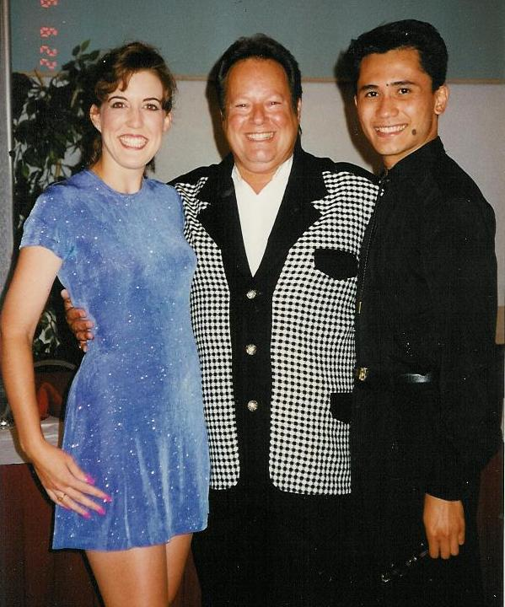
The Nightclub or California Two-Step was originated by Buddy Schwimmer, Lee & Linda Wakefield, & Ron Montez during the 1960s and ‘70s in crowded dance clubs on the west coast as a rhythm that lets you really dance to slow love ballads. Schwimmer once said:

It's the alternative to the "Why" dance. That's a dance where you stand, put your hands by your partner's waist and your partner puts her arms around your neck. You just step back and forth, back-and-forth for a while and then say: "Why dance? Let's just go home." The non-dancers do that. It's a lack of knowledge and lack of technique and that's why they do it that way. After five drinks, everyone thinks they are a wonderful dancer.
(full interview at http://www.lovemusiclovedance.com/niteclub.htm)

The Nightclub Two-Step encourages you to draw out a side step and use up some of the "extra" time that way. Schwimmer taught the dance as a quick rock, recover, and then side; or a cross behind, recover, side. This form of the dance is certainly more “Two-Step”–like, but from the beginning, round dancers have danced a slow side step and then the rock-recover—slow, quick, quick. In 1992, Bill and Carol Goss published a cue sheet for Kiehm's Are You Still Mine, and they wrote Even Now and Evergreen. Jim & Bonnie Bahr released What Am I Living For in 1993.

Timing—

Most choreography is written as though the timing of the figures is "slow, -, quick, quick;" and if the music is 4/4, that is a good description, but if you have good 6/8 music, it would be better to think of the timing as “slow, , , slow, ,&;" but even this representation is approximate. Out of the six beats of music, the first step uses three, the second uses two, and the last is a quick of just one beat. That third step puts you into the next measure, the next slow step, very quickly. (If you read cue sheets, then the punctuation in this paragraph maybe didn’t seem odd. If not, let me say that we’re trying to use a comma to mark the end of a beat and a semi-colon to mark the end of a measure of music.)

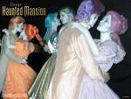
Rock step—

In a facing position, such as closed or butterfly, step side with the lead foot, cross behind (woman also) with the trail, and recover; repeat with the trail foot: side, -, cross behind, recover;

The rocking step is a tight one. Don't rock apart as you might in jive or swing, but turn the foot out and place toe to heel. Don't take weight fully, but quickly push back onto the initial supporting foot. There should be no up-and-down bounce, but a little side-to-side bounce.

Character—

On the surface, Slow Two-Step is similar to Bolero (that initial, slow, side step). More often than Meredith and I like to admit, we haven't paid attention to the cuer's introduction, the dance has started, the cue is "Basic," and we just try something (Slow Two-Step, Bolero, Rumba?). But Bolero is usually slower, smoother, more sensual (more Latin?). Bolero has conspicuous rise and fall. Slow Two-Step is a little faster, sharper, peppier. It is up and flat—little rise and fall. Dance it with soft knees, yielding only subtle hip movements. There is certainly no “Rumba” or Cuban or Latin hip. Sometimes, you can feel a little of the character of Jive or Swing and sometimes Foxtrot. It’s a hybrid rhythm.

Of course, each rhythm has its own characteristic figures. The Half Moon is Bolero, and the Triple Traveler is Slow Two-Step. However, we have to remember that round dance choreographers are not the least bit shy about borrowing figures from other rhythms. In a Slow Two-Step, you could easily find a New Yorker or Fence Line (maybe even a Half Moon) from Bolero, or a Vine or Wheel from Two-Step or even a Bota Fogo from Samba. (we’re looking at the Shibatas' What A Wonderful World, right now.)

Inside & Outside Rolls—

Slow Two-Step originated as a tight, slot dance—in place, back and forth along the line of dance, hemmed in by the nightclub crowd—but we have come to travel more and more in this dance, and one place we do this is where we roll. I say “we,” but of course it is the woman who does most of the rolling.

The Lady’s Inside Roll is any left-face (reverse) underarm turn done by the lady. For instance, in a facing position with trail feet free, you might step side right (woman side left beginning to turn left face under lead hands), thru left (woman thru right turning), and side right to face (count “slow, quick, quick; (sqq)). In the Rumbles’ Can’t Help Falling In Love, the introduction begins in butterfly sidecar facing reverse and wall. The man steps forward left (woman back right for a Develope); then he recovers right and the lady does an Inside Roll toward line of dance to loose closed position facing wall; for a Basic;; In the Reads’ You Raise Me Up, part B starts with Basics;; Traveling Right Turn; Outside Roll; Lunge Basic With Inside Roll; Basic Ending; (again, in sequences like these, we’ll use each semi-colon to mark the end of a measure of music.)

The Left Turn with Inside Roll begins in loose closed position, lead foot free. The man steps forward turning left face, raises lead hands, and brings them between the couple to lead the woman into a left face turn (here is the Inside Roll part; notice the lead hands move “inside” the couple). The second step is side right, turning. The last step is a cross in front while the woman steps side right continuing her turn to face partner. The hard way to do this figure is to begin facing wall and to turn 1/2. More often, the preceding figure will be modified, as in “basic ending to a pickup,” so that the left turn is begun early, and the figure then needs only to turn 1/4. In the Rumbles’ A Whole New World, part A starts with an Underarm Turn; Basic Ending; Left Turn with Inside Roll; and a Basic Ending;

An important feature of this and many other Slow Two-Step figures is the third step of the measure, which crosses in front for the man. Something often makes us want to cross behind, but doing so breaks our connection with the woman and makes it harder to progress along with her. Make that third step forward and thru—you’ll stay together better.

The Lady’s Outside Roll is any right face underarm turn done by the lady.
For instance, we do one in the third measure of a Triple Traveler. We might be in left open position, both facing line of dance, lead feet free, and lots of other choreography could put us in this position for an Outside Roll. He steps forward left (woman forward right beginning to turn right face under joined lead hands), forward and side right turning left to face partner (woman side left continuing to turn right), and cross left in front of right (woman forward right) to end in left open facing position (sqq). Starting with the man on the outside of the circle, he will end facing center of hall, trail feet free. The figure may be done from a variety of starting positions and alignments. In the Rumbles’ A Whole New World, there is an Inside Turn Pickup to handshake; Open Break; Lady’s Outside Roll to a side-by-side position man facing wall and woman facing center; In the Reads’ Stranger On the Shore, there is a sequence that begins in half open position, lead feet free. The man steps forward, Maneuvers, and Pivots; to a Rudolf Ronde and he changes sides under lead arms to end in left open facing position, man facing center of hall; lady Outside Roll; Basic Ending; Left Turn with Inside Roll; Basic Ending to face wall;

The Right Turn with Outside Roll begins in loose closed position, lead foot free. The man steps side and forward turning right face, and raises lead hands, moving them sort of around in back of her head (“outside” of the couple, rather than between your faces or “inside”) to lead her into a right face turn. Step side and back with right foot as woman steps forward under lead hands. Finally, cross left in front of right to face, and she will step side, finishing her turn, also to face. This figure, too, can be done the hard way, incorporating 1/2 turn, but more often the previous figure is modified, as in “Basic Ending to a Maneuver,” so that the turn is begun early, and the figure itself then needs to turn only 1/4.

We first ran into the Passing Outside Roll in the Read dances. In a facing position, perhaps line of dance, the man steps forward left (woman forward right toward man’s right side) to right/right forearm contact, he pauses and raises his right arm leading the woman to turn right face. The woman steps forward left turning right face under right arms. He holds the second “quick” too, now facing wall, and the woman steps back right to face line of dance and joins right hands (sqq). Note that the man only takes one step and turns 1/4 right face as he leads the woman’s underarm turn. The woman takes three steps and turns 1/2 right face as she passes from one side of the man to the other (in this case, from the line of dance side to the reverse line of dance side). The figure can be done from other facing positions. In the Reads’ You Raise Me Up, there is an Open Break, man facing line of dance; Passing Outside Roll; to a Check Ronde and Back Pass; and lady around to face;

Finally, let’s look at a new figure that is much like the Inside Roll for both the man and woman, the Flip Flop. In facing position, arms at sides, step side left and turn sharply 1/2 right face (woman side right and turn 1/2 left face), step side right (woman side left) and turn sharply to face (ss). In Tim & Nana Eum’s Face To Face, there is a syncopated vine 4 to face partner and wall; Flip Flop twice;; Side Basic; Reverse Underarm Turn to sombrero position; and Wheel 6 to face center of hall;;
