Slow Two Step, Left Turn With Inside Roll
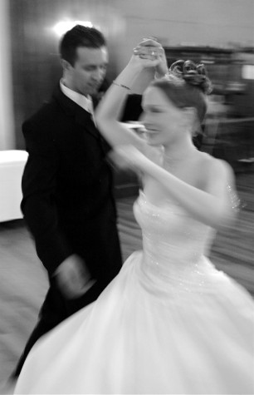
by Harold & Meredith Sears

In loose closed position, lead feet free, step forward left turning left-face (woman back right), raise lead hands, and bring them between the couple to lead the woman into a left-face turn (an inside roll; notice the lead hands move "inside" the couple). The second step is side, turning, as the woman turns under joined lead hands. The last step is a cross in front while the woman steps side right, continuing her turn to face partner. The timing is SQQ.

The hard way to do this figure is to begin facing the wall and to turn 1/2 (woman 1 1/2). More often, the preceding figure will be modified, as in "Basic Ending picking up," so that the left turn is begun early, on the last step of the preceding figure, and the Left Turn With Inside Roll itself then needs to turn only 3/8 - 1/4. Even if the cuer doesn't give the "helper cue" -- "picking up" or "to a pickup," you will hear the cue itself while you are doing that Basic Ending, so you can modify the last step yourself, with a little left-face rotation, and so be in position, facing DLW or even LOD rather than WALL, for an easier, smoother Left Turn With Inside Roll.

An important feature of this and many other slow-two-step figures is the third step, which crosses in front for the man. Something often makes us want to cross behind. Maybe we're thinking about a vine. But doing so breaks our connection with the woman and makes it harder to progress along with her. Make that third step forward and thru—you'll stay together better.

