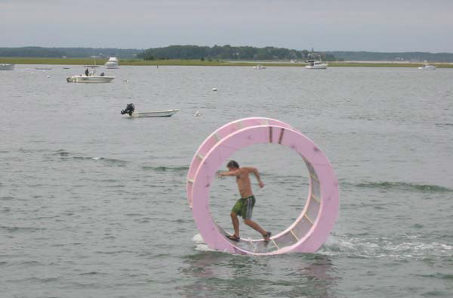
Tipples, Ripples, and Body Rolls

by Harold & Meredith Sears

When you think about Body Rolls, you might first think of samba. In Chris & Terri Cantrell’s Bailamos, we have a Left Turning Box with Barrel Roll action, and the Roundalab manual includes a Natural Roll (which I don’t think Meredith and I have encountered yet). Or you might think of the in-place picture figures that show up in a variety of rhythms—“back to a Leg Crawl and Around the World.”

No matter what you call this action—Body Roll, Barrel Roll, Around the World…—the move is basically the same. You lower and lean in some direction so that your upper body moves outside your base of support, and then you rotate (one way or the other) in a broad arc.

Lately, we have been running into this Body Roll feeling in some Tipple and Ripple Chassés, and it’s been fun.

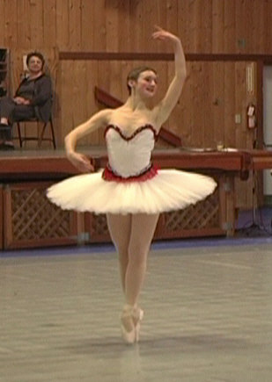
Chassé—

In French, chasse is a chase, chasing, pursuit. Chassé ("sha-SAY") is a ballet term and refers to one foot "chasing" the other, displacing it from its spot. In round dancing, the steps are side, close, side, and may begin with either foot. The figure usually occurs at the end of a measure (e.g. 2&3 in waltz), and partners are facing each other with shoulders parallel.

A Forward Chassé uses a full measure. In open position, we might step forward with the trail foot turning to face our partner, and then step side/close, side, ending in semi-closed or some other designated position.

A Thru Chassé or Semi Chassé begins in semi-closed position, and we step thru with the trail feet turning to face partner and then side/close, side.

A Turn Left and Right Chassé might begin in closed position facing line of dance. We step forward on the left foot (woman back right), begin turning to the left, and step forward & side R/close L, side R to banjo position facing reverse and center. The figure can begin and end in other positions and with either foot. For instance, you might dance Back and Right Chassé or Turn Right and Left Chassé.

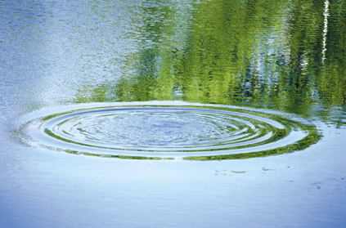
Ripples & Tipples—

Adding a “ripple” or a “tipple” to your Chassé is a matter of using side stretch to incline your shoulders as you progress. Don’t just drop one shoulder or raise the other, but incorporate sway into your whole torso. Swaying or directing your shoulders away from your line of progression is a Ripple. Swaying toward your line of progression is a Tipple.

So, a Ripple Chassé begins in semi-closed position. You step thru with the right foot (woman thru left) turning to a contra banjo position. The chassé begins with a side and forward L/close R with left-side stretch and looking right (woman left) ("closed heads"). This stretch is the "ripple:" tipping the upper body away from the direction in which you are going. Finally, step side and forward L again blending back to semi-closed position. (May also end in contra banjo position.)

A Tipple Chassé or Back Tipple Chasse begins in closed position facing reverse line of dance. The man steps back with the left foot (woman forward R) turning 1/4 to the right. He steps side R/close L with slight left-side stretch. Again, this stretch is the "tipple:" tipping the upper body in the direction of progression. Finally, he steps side and forward R with another 1/8 turn to face line and center in closed position. The figure may begin with the trail foot in which case the turn would be to the left, the stretch right-side, and the ending orientation line and wall.

A Tipple Chassé Pivot is not a standard figure but a combination of the Tipple Chassé and a one-step pivoting action done on the last step of the Chassé. The man steps back L turning right (or back R turning left), side/close (with sway toward the direction of progression) turning 1/8, and then side and forward pivoting 1/2 for a total turn of 7/8.

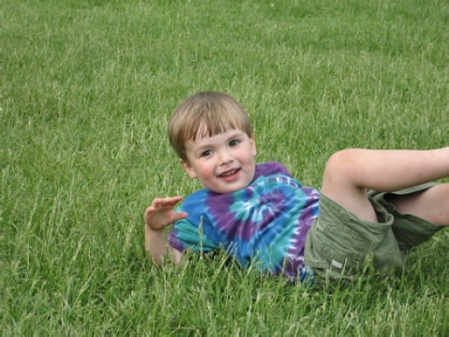
Body Roll Actions—

There’s a fun pair of tipples in the Goss quickstep, We Are In Love. We’ve just done a forward, lock, forward, so we’re in banjo position progressing down line of dance with trail feet free, and the cues are—Forward Tipple Chassé, Back Lock Back, Back Tipple Chassé, Forward Lock Forward, to a Maneuver. The sways and changes of sway are wonderfully swoopy with a “Body Roll” sort of feel. The man steps forward on his right foot and begins to turn to the right. He uses right-side stretch to sway left. She opens her head, and he looks left, about toward the wall. Bill Goss talked about looking over a fence, maybe surrounding a nudist colony just over there beyond the dance floor. Then we blend back to banjo facing reverse for our back lock back. Here, the man would have a little right sway and right-side lead progressing backward down line. He then steps back on his left foot and turns to the right for the second “tipple.” He keeps the right sway. He looks right and she looks to her left. Again, we are looking over the same fence. Well, the first look was so interesting that we had to look again, but the feel is almost nautical, riding the ocean swells—he has left sway during the first tipple, and then up and into right sway during the second tipple—a graceful “Body Roll.”

There is a similar action in the Moore foxtrot, Breathless, where we do a Back Tipple Chasse with Left Sway & Pivot to a Back Feather. For the first figure, we are in closed position facing reverse line of dance with the lead feet free. The man steps back on his left foot (woman forward R), turning to the right and shaping to the left. That is, we use right-side stretch to sway left as we step side right/close left, continuing to turn, forward right toward diagonal line and wall. Finally, we remove the sway and pivot on that right foot to face reverse again.

This figure caught me off guard. Brent presented it so casually, as though it was a completely normal option—let’s do a Tipple Chassé with left sway rather than with right sway—six of one; half a dozen of another—and I’m thinking in this obsessive sort of way, wait a minute, this tipple has to have right sway. If we do left sway, it’s not a tipple. Is it a ripple?

Well, given that Roundalab only gives us two options: a Forward Ripple Chassé and a Back Tipple Chassé, then obviously we do have the Back Tipple here with a modification in the sway. The reward is a warm glow that you get as you swoop from the initial left sway into the subsequent right sway and right-side lead of the Back Feather—a soaring kind of rolling feeling that is really quite charged.

Finally, just to show that you don’t need a Chassé in order to get this rolling action, consider the Traveling Right Turn to an Outside Roll in the Read slow two-step, Stranger On the Shore. It was Ron & Ree Rumble who taught us this one, at the CRDA Gala last November, and he was full of giddy enthusiasm over the rolling sway changes here.

We are in closed position, facing the wall. We turn to semi-closed and step forward left across the line of dance and turning to the right. Here, we use left-side stretch and a right head to sway toward the center of hall (woman forward R with left head). And that right sway does feel a little like a Ripple, even though we’re not doing a Chassé at all. That was a “slow” count. On the first "quick," the man crosses his right foot behind his left with partial weight to prepare for something like a Twist Turn. He does a delayed weight change and a change of sway to the left (woman forward L with left-side lead unwinding). On the second "quick," he steps back L with left sway, still swaying toward center of hall (woman forward R) to banjo position facing line of dance. The next figure is a Lady’s Outside Roll to face wall again.

What we did was to sway right as we began the turn and then roll into a left sway as we come out of the turn—whoosh.

All of these sequences simply involve a sway in one direction, followed by a rolling sway change to the other direction. By itself, sway helps us make the turn, sort of like banking a bicycle around a curve. Sway also creates attractive body lines—I suppose graceful slopes and curves are simply more “artistic” than vertical lines and right angles. And now, we’re starting to think about the transition from one instance of sway to the next. Instead of isolating our Left Sway, Lose the Sway, Right Sway, we’re rolling from one to the other in a fluid arc. We have one motion, now, instead of three. It feels good, and it looks good too.

