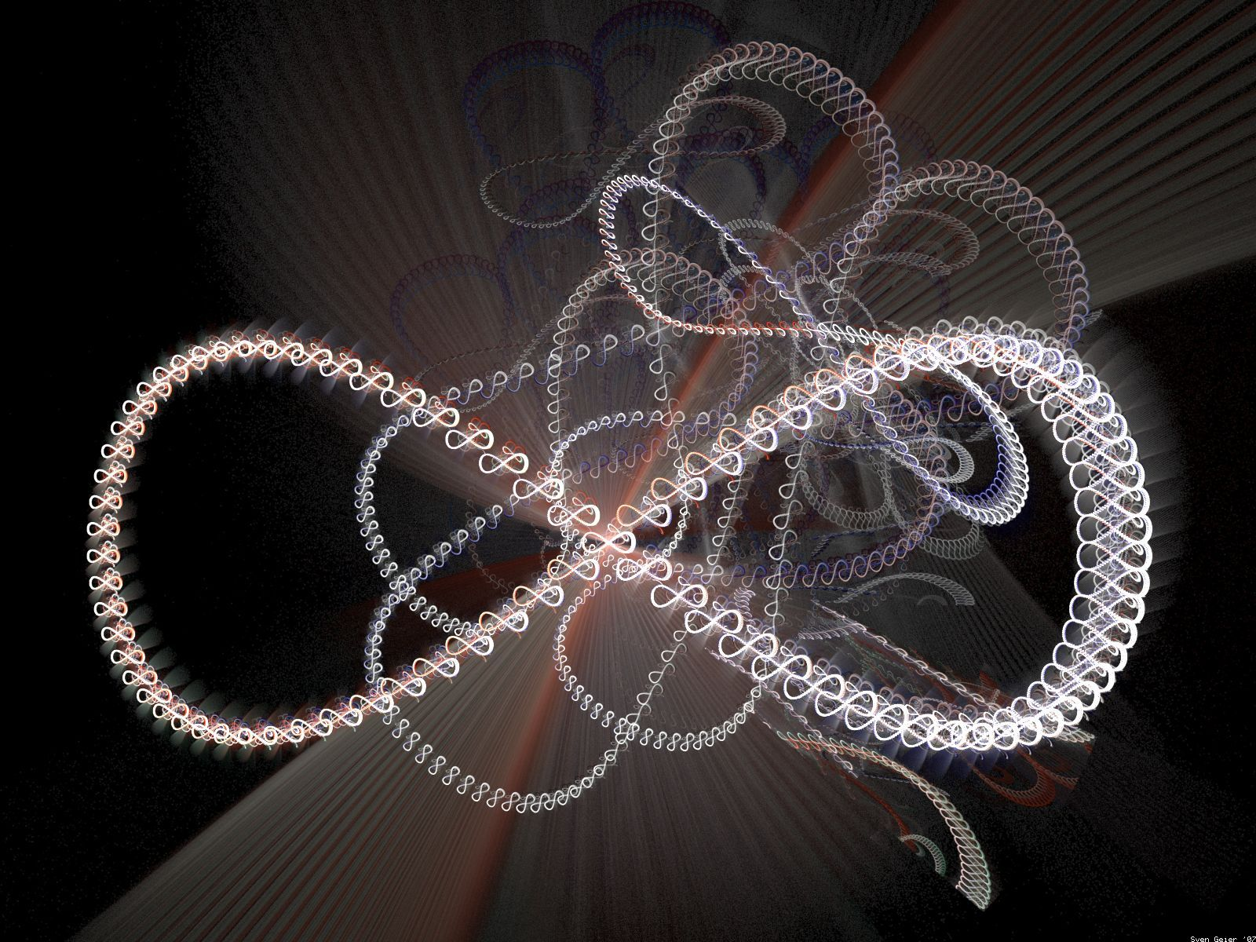
Twists, Twist Turns & Hip Twists

by Harold & Meredith Sears

One of the common actions in round dancing is the twist. There are twists in all the rhythms, from Two-Step to Paso Doble, and there are twisting actions in dozens of different standard figures. However, it seems that we might be able to take all of these actions and organize them into just two distinct categories — the Twists, which are in the hips, and the Twist Turns, which occur down in the legs. If we can be clear about the difference between a Twist and a Twist Turn, and if we can be clear about which action is called for in a specific figure, then perhaps we can execute these figures more cleanly. Perhaps.

Twists —

A Twist is a simple, phase II action. The dancer turns her hips independently, or at least more, than the upper body and so puts a “twist” or a bit of a spiral into the torso. Think of the beginnings of a spiral staircase or a DNA molecule. The hips might have been turned to face line and center, but the shoulders are still facing center of hall. One popular dance has a “lunge and twist, behind, side, through.” It was only the hips that “twisted.” The shoulders and head did not turn.

The Twisty Vine is a figure that begins in a facing position, man probably facing wall. And through all of the twists, his head and shoulders should continue to face the wall. He steps behind with his right foot, as the woman crosses in front. He steps side left, crosses in front right, side left. Your hips are turning back and forth with each crossing step, but your upper body is turning relatively little.

In the Rumbles’ A Whole New World, a phase VI Slow Two-Step, they begin with a Twisty Basic. Rather than both stepping side, crossing behind, and recovering (the standard Slow Two-Step Basic and a mirroring action between partners), the man steps side with the left, twists a bit right, and crosses behind with the right, and the woman steps side right, twists a bit right, and crosses in front left, and both recover onto the lead foot (more of a following action). This Half Basic is like the beginning of a Twisty Vine. But we keep the shoulders aligned, and turn the hips only. This makes it a true “Twist.”

In the Easterdays’ Slow Shag, a phase IV Jive, they have a figure, “twist down 4 and up 4.” In butterfly, with feet together and weight evenly distributed, we swivel L, R, L, R, steadily lowering into the knees, and then repeat while rising, and finally releasing lead feet. We’re not used to having both feet weighted, so we might dance this as a swivel left-face/step left, swivel right-face/step right, and so on, but such a pattern would come close to “skating left and right” and might lead us to turn the whole body, rather than the hips only. So, keep both feet weighted and think Chubby Checker and The Twist (~1960).
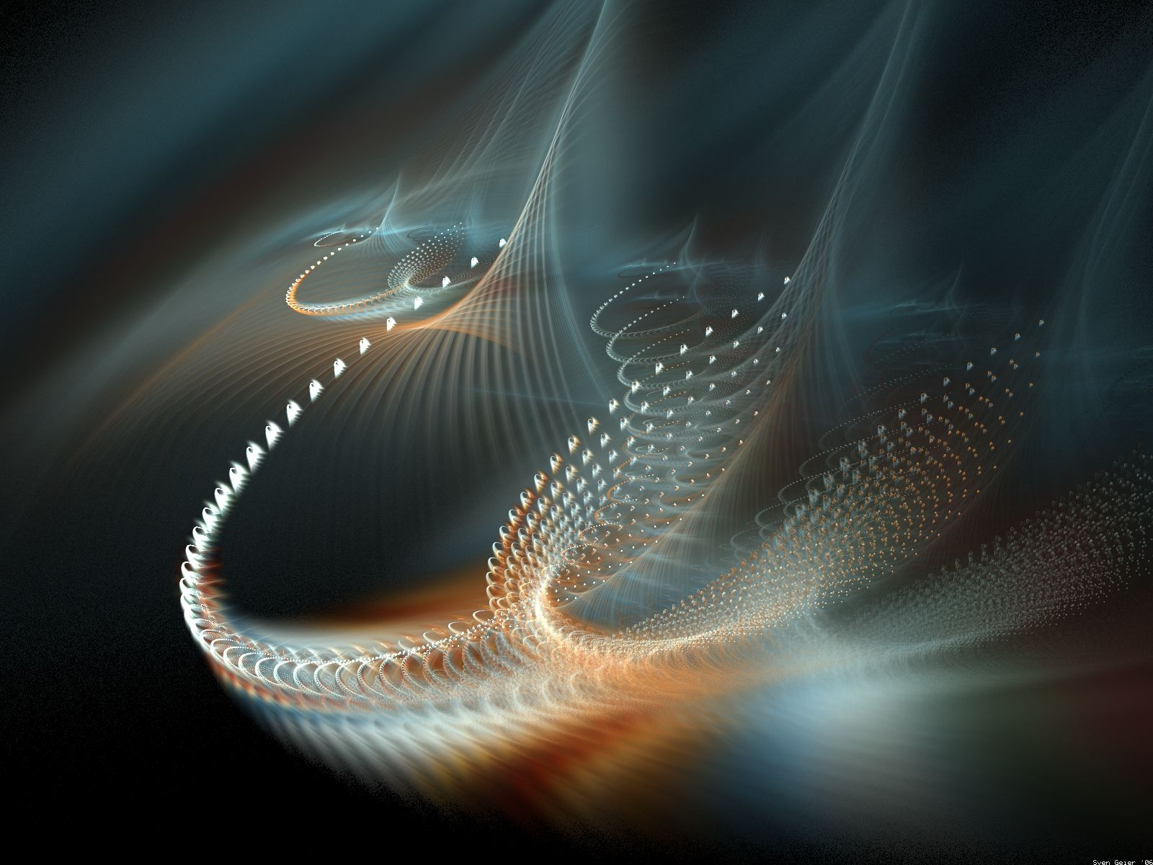

Hip Twist —

If you look at the above examples closely, you will see that the term, Twist, is quite generic. It applies to any action in which the hips turn more than the upper body. The term, Hip Twist, is a little more specific. In a Hip Twist, the hips turn in the direction of the weighted foot. If you are standing on your right foot, a Hip Twist is to the right, and this is usual for the woman. If you were standing on your left foot, then a Hip Twist could be to the left. (A turn in the direction opposite to the weighted foot is a Spiral, although a full Spiral turns much more than a typical Hip Twist, up to 7/8).

In several different Latin rhythms, we have standard figures that are named “Hip Twists.” Think of the Open Hip Twist in Rumba (phase V). In left open facing position or in a handshake, the man steps forward left on the first quick count (woman back right), he recovers right on the second quick (woman recover left), and he closes left with tension in the joined arms on the slow count (woman steps forward right toward man and then swivels sharply right-face on the "&" of the third beat). An important feature of this figure is that the Hip Twist is initiated through the hips and the hips turn more than the upper body. The feet may have swiveled to line of dance, and the hips might have turned all the way toward line, but the upper body lags behind, maintaining connection with your partner. The Closed Hip Twist and the Advanced Hip Twist begin in closed position, and they start with strong opening-out actions, but the Hip Twist within the slow count has these same features.

Men Can Hip Twist —

In round dancing, the women usually get the flourishes — the turns, spirals, spins, and twists — but men can Hip Twist, too. You might do a Hip Twist Chasse in a Cha-Cha as you lead your woman to a Fan. Perhaps you have just done an Open Hip Twist. To then lead her to a Fan, step back right, as she steps forward left down line of dance, recover left as she turns 1/2 left-face and steps back right, and here’s the Hip Twist Chasse on the 3&4 counts — cross right foot in front of left, turning hips left-face, close left to right turning hips right-face, and step side right. This footwork automatically produces a little Hip Twist in the man, and the crossing action moves him briefly toward the woman and so leads her back/lock, back, into fan position (the standard side chasse moves him only away from her).
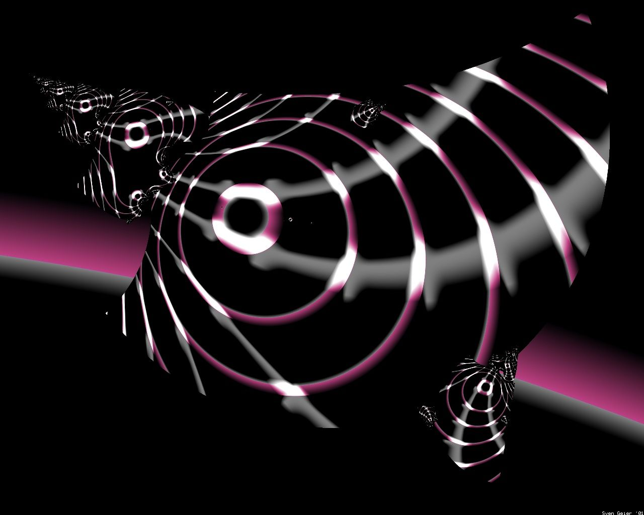
Another figure in which the man gets to Hip Twist (along with the woman) is the Jive Coca Rola (phase VI). Usually in a side-by-side position, perhaps facing line of dance, with same footwork, swivel 1/8 right-face on the right foot, lower into the knees, and step forward left. On the second beat, swivel 1/4 left-face on left, rising, and step back right. On beat 3, swivel 1/4 right-face on right foot, standing high and proud, and step side left. Finally, swivel 1/4 left-face on left and cross right in front of left to end almost in the original position but with the hips turned toward line and center. You might repeat for a second measure. You can think of each one of those swivels as a Hip Twist, with the shoulders fairly still and facing line, while the hips twist back and forth. This figure feels rather Chubby Checkerish, too. Without the Hip Twists, this figure is sometimes choreographed as a "Jazz Box.” Simply step across in front, back, side, and cross in front (maybe phase IV?).

Twist Turns —

Now we come to the Twist Turn. This action has the term “Twist” in its name, but there is no Twist, as described above. The Twist Turn is really more of an “Unwind” and usually for the man. He hooks his right foot behind his left with partial weight, and in Waltz, she steps forward left/right around him. On beat 2, she steps forward left turning right-face and continues to unwind him. He gradually shifts his weight to his right foot. On the last beat, he steps side and back left, and she steps between his feet right to end in closed position.

The Spin and Twist is the familiar figure (phase VI) that incorporates the Twist Turn. We usually begin in closed position facing reverse line of dance with lead feet free. The man steps back commencing a right-face pivot with left-side stretch, and the woman steps forward right between his feet. He steps forward right between the woman’s feet continuing to turn, and then steps side left to face diagonal reverse and wall. During this first measure, we are dancing an overturned Spin Turn. Now, the trail feet are free. The man hooks his right foot behind his left, and she unwinds him as described above. We end in closed position facing diagonal wall, wall, or even diagonal reverse and wall. There is a 1 5/8 to 1 7/8 total turn.

One way to think of the Grand Circle (phase V), in Paso Doble, is as an extended Twist Turn where the man crosses his right in front of his left, and the woman walks around him left-face, unwinding him with eight or more elevated prancing steps over two or more measures.

In tango, we do a Natural Twist Turn (phase VI), which of course contains a very similar, unwinding Twist Turn. Beginning in semi-closed position, the man steps side and forward left (woman side & forward right) on a slow count. He steps forward right blending to contra-banjo on a quick, and turns right-face and steps side left across the woman's line of dance (she steps forward right between man's feet) on the second quick. In the second measure, he does his Twist Turn. On the “slow,” he crosses right in back of left with partial weight, and the woman steps forward left with left shoulder lead. On the first “quick,” he unwinds right-face to semi-closed position facing DLC, and she steps forward right to banjo position and swivels right-face. On the second “quick,” he shifts weight to his right, and she steps side and back left into a tap position. A nice modification is to dance that second measure Twist Turn with a quick-quick-slow timing. You unwind a little quicker, snap into the tap position earlier, and then have a beat in which to hold the “picture.”

So, you can Twist with your hips, and you can Twist Turn through your legs. They are both graceful and attractive, but they are quite different actions.

Single, Double, and Triple Twist Turns

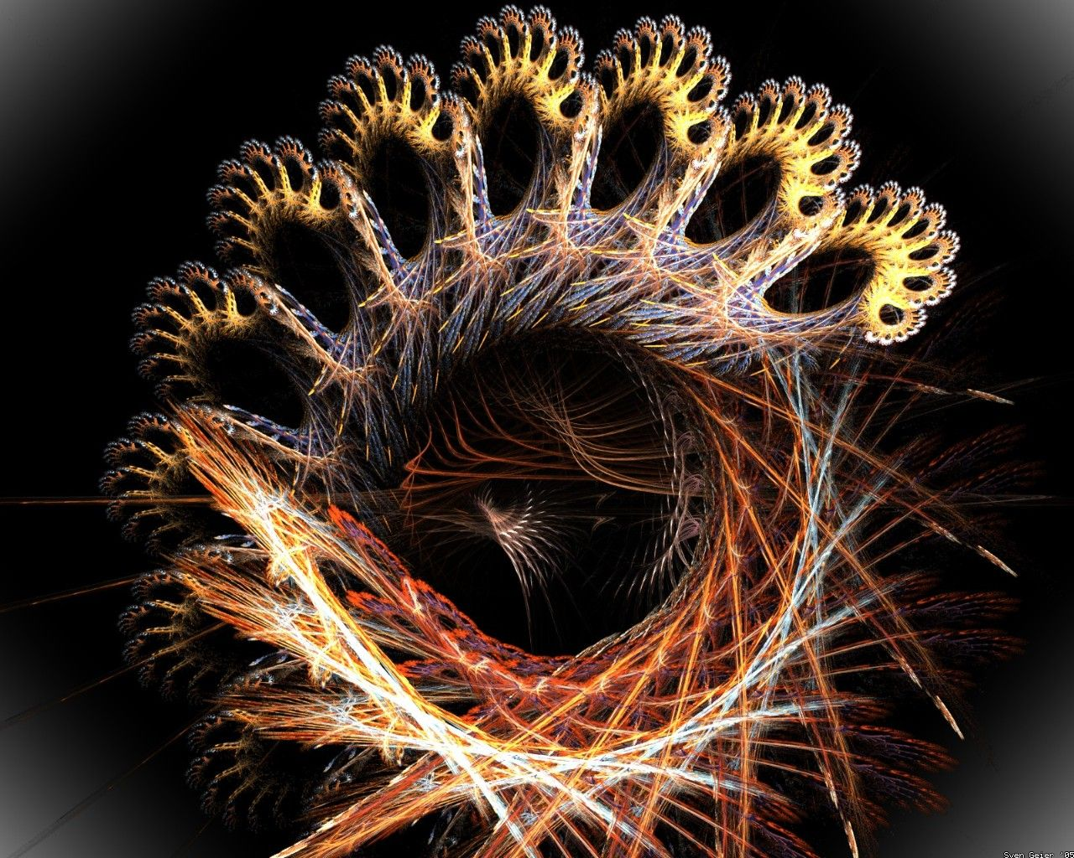
The Twist Turn is not a Roundalab standard figure, but we dance it in various combinations. Usually, we Spin Turn to a Twist Turn (Spin and Twist), but sometimes we Outside Spin or Royal Spin to a Twist Turn. The Worlocks’ Adagio begins with a Contra Check; Switch & Hook; to a Twist Turn to semi-closed position. Could we do a Running Open Natural; check it to a Twist Turn?

A Twist Turn usually begins in closed position, facing reverse line of dance, trail feet free. The man crosses behind and unwinds. The woman runs right face, unwinding him. We usually end in closed position facing diagonal wall, wall, or even diagonal reverse and wall, depending on the choreography.

Let’s look at this a little more closely. A Twist Turn really begins with upper body rotation to the right, flowing out of the previous figure (e.g., Spin Turn). The man steps back on his right foot. The rotation gives the back step a crossing-behind component. Then, using pressure into the right toe and the left heel, he unwinds to a very neat side-by-side foot position, rises to the balls of the feet, and changes weight to the right foot. The count in waltz is 1/&. During the “1” half of this beat, he is evenly weighted on both feet and unwinding. Toward the end of the “&” half of the beat, he shifts weight fully to his right foot. The woman has stepped left/right to the outside of the man in a right face arc. She is on the balls of her feet. On beat 2, the man continues to turn on the ball of his right foot, and the woman steps forward left and turns with him. On beat 3, he steps side and back left, and she steps forward right between his feet to closed position, trail feet free again.

Sometimes the first step of a Twist Turn is described as a “hook right foot behind left foot.” If you truly hook the right foot so the front of the ankle is touching the back of the left foot, you’ll be unstable, and your unwind will leave your feet separated, not together. So make that step a back crossing step, not a tight hook.

Notice that there are two weight changes for the man and four for the woman. In waltz, the timing will be 1/&23. He takes full weight at the end of the “&” or even into the “2” and then steps side and back left on “3.” She steps L/R, L, R; in a rather high, balls-of-the-feet run. In foxtrot and quickstep, the timing is q/&qs. Similarly, he takes full weight at the end of the first “quick” and then steps side and back left on the “slow,” and she dances L/R, L, R, -. Various sources allow waltz timing of &/123 and foxtrot and quickstep timing of &/qqs, qq&/s, or even &/sqq. We’ve always been skeptical of those who say, “the music tells you what to do,” but the music often does tell you when to do it and so helps you to choose among these options.

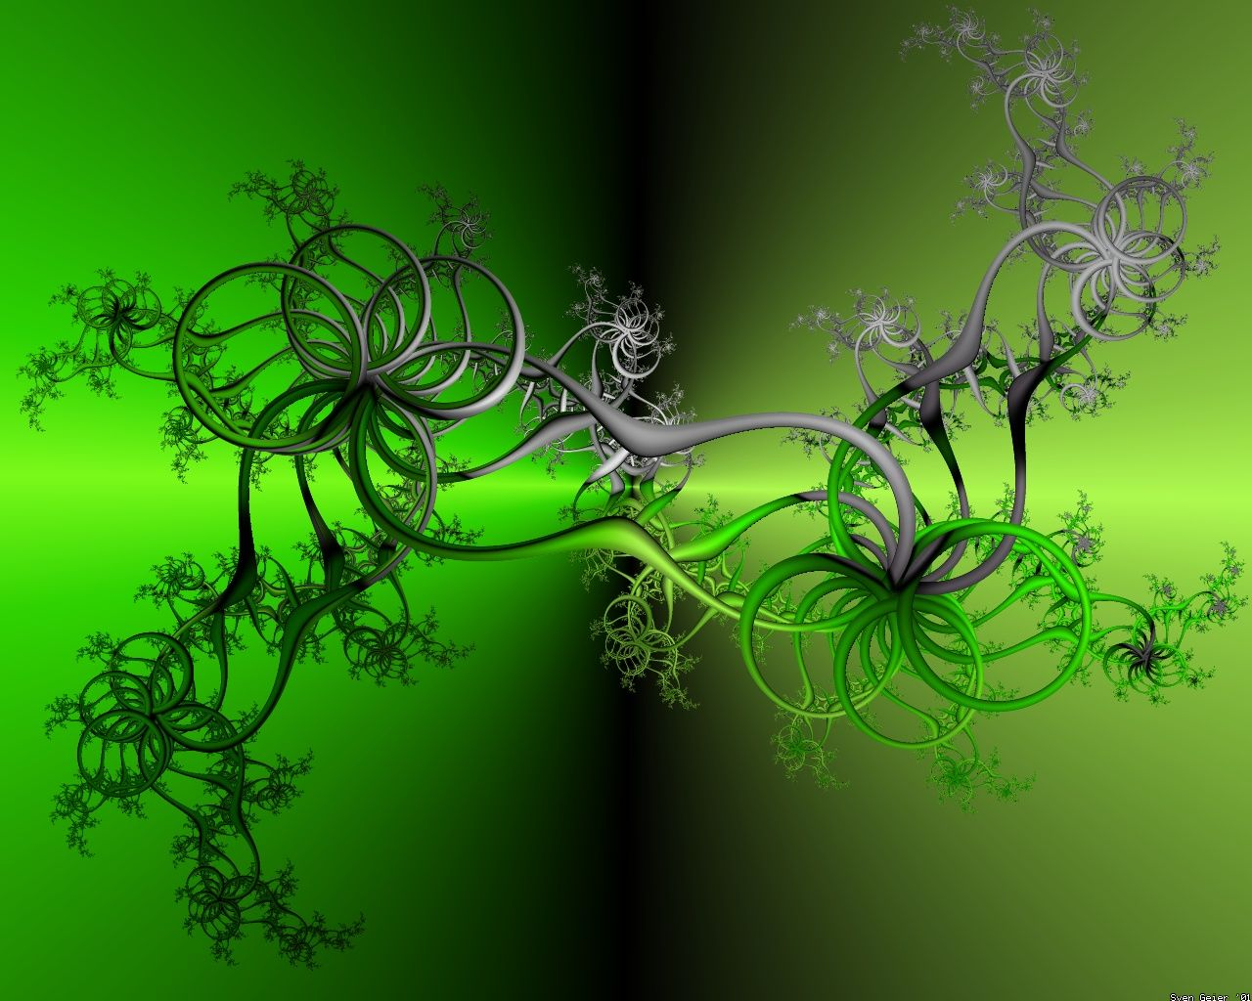
Spin and Twist

Again, the Spin and Twist is the familiar figure (phase VI) that incorporates the Twist Turn. We usually begin in closed position facing reverse line of dance with lead feet free. The man steps back commencing a right-face pivot 1/2 with left-side stretch, and the woman steps forward right between his feet and pivots. He steps forward right between the woman’s feet continuing to turn, and she steps side and back left and draws right to left. On count 3, he steps forward and side left turning to face diagonal reverse and wall, and she does her heel turn, changing weight to the right foot. During this first measure, we are dancing an overturned Spin Turn. Now the trail feet are free. The man crosses his right foot behind his left, and she unwinds him as described above. We end in closed position having made a 1 5/8 to 1 7/8 total turn. There is even a common variation, the Spin and Twist to Semi, that underturns the Twist Turn to closed position facing line and wall on count “2” and then rises with right-side stretch for an exit—man side and forward left, woman side and forward right—to semi-closed position facing line and center.

Spin and Double Twist

The Spin and Twist is so much fun that we will certainly want to do a Spin and Double Twist. In this figure, you simply do a Spin and Twist overturned to face reverse, and then do another Twist Turn. This would give us 2 5/8 to 2 7/8 total turn over three measures.

One of the problems inherent in this "Double Twist Turn" lies in the long side step with the man’s left foot that overturns the first Twist Turn and prepares him to do the second Twist Turn. It can become an abrupt leap that disturbs the smooth flow of the waltz. Again, a Twist Turn for the man involves two weight changes. He crosses his right foot behind his left. She unwinds him. He takes full weight on his right as late as beat 2, and then steps side left on beat 3. You can smooth out a Double Twist Turn by taking four weight changes, instead of only two, and by making the third step a progressing pivoting step. On beat 1, cross the right foot behind left taking weight and step left, as she begins to unwind you (1/&). On beat 2, step forward right between her feet and pivot right-face in a maneuvering action, and then step small side left to set up for the second Twist Turn. The count becomes 1&23; just as it is for the woman, and the flow is so much smoother than the usual "cross/unwind, -, leap." Jim & Bonnie Bahr used this smoother, progressing version of the Double Twist Turn in their Red River Waltz. It flows so well that we think even a Spin and Triple Twist would be comfortable.

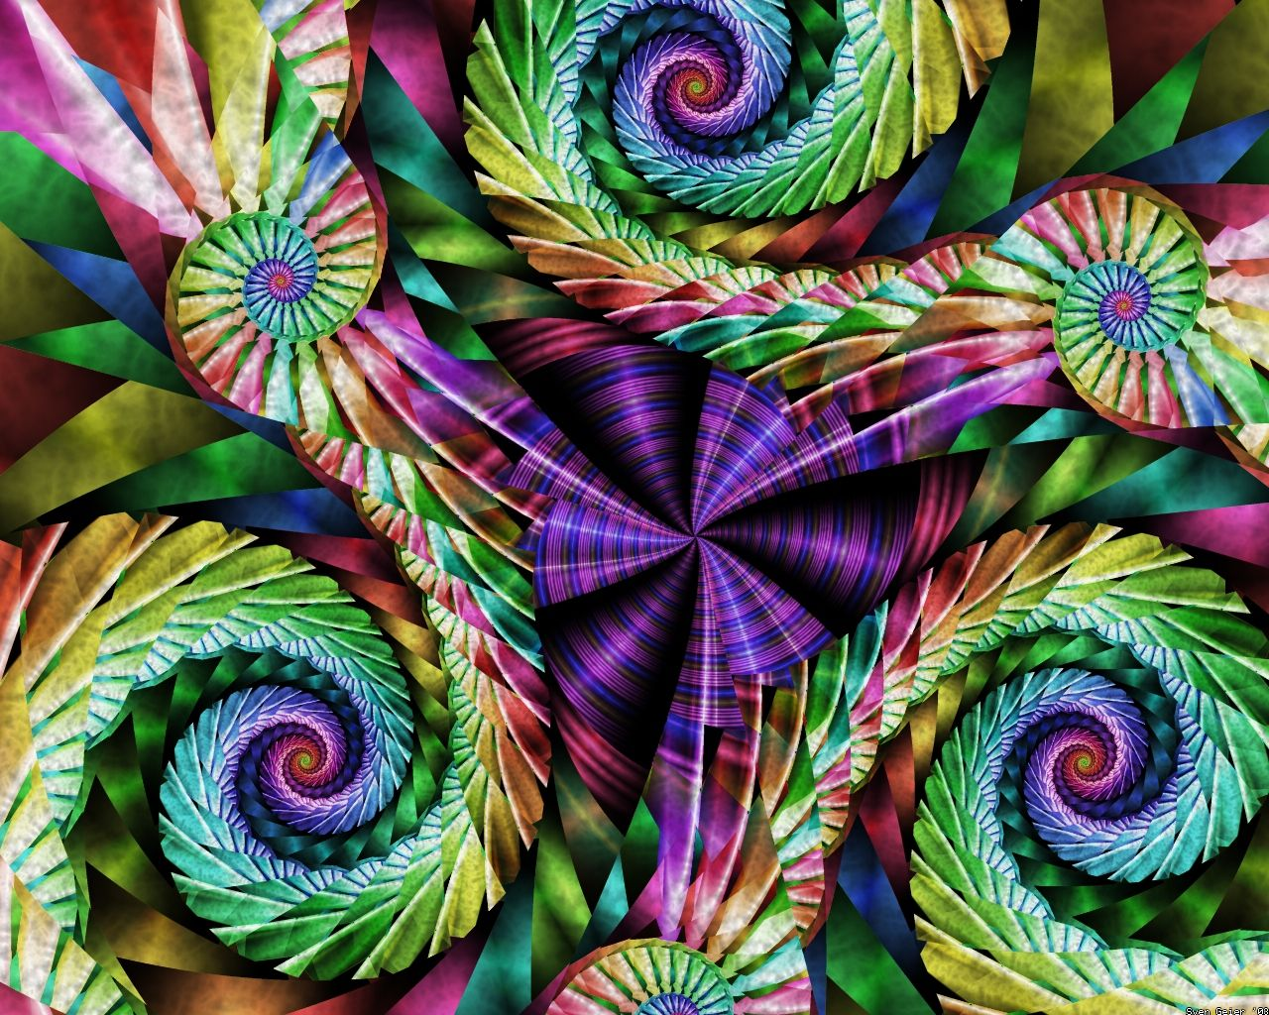
The Twists

And indeed, Paso Doble has a figure that is called The Twists that begins with one measure of even-count preparation and then contains three syncopated Twist Turns in measures two and three.

We begin in closed position facing wall with the trail feet free. On the first beat, we Appel with the trail feet and turn to semi-closed position, lowering. The man steps forward left, maneuvers right, and steps back and side left to closed position facing reverse and wall.

Although the actual count for the complete figure is 1234; 1&234; &123&4; it will probably help to count measures two and three like this: 1&23 1&23 1&2. These are the actual "twists." For each “twist,” the man crosses his right in back of left, unwinds right-face, and steps left on the “1&.” The woman runs forward left and forward right outside partner turning right-face and ending in banjo position, man facing line and center. On the “2” and the “3” counts, he steps forward right outside of partner pivoting right-face (woman back left), and then side left (woman close right in a heel turn) to finish the “twist” in closed position and facing reverse and wall again.

At this point, we have used only three of the four beats of the second measure, but it feels as though we have done a whole "thing." We have done one syncopated Twist Turn. Now, do another full “twist,” 1&23, and end the figure with the first three steps of a third but under-turned “twist,” 1&2. For this third “twist,” cross your right in back of left, unwind right-face, and step left (woman forward left and forward right outside partner turning right-face) to banjo position, man facing line and center, and then close right to left blending to closed position facing line and center, lead feet free. This completes three full four-count measures.

We first encountered The Twists in Chris & Terri Cantrell’s Silverio. They begin part B with The Twists;;; curve left two to face center of hall,, point left /close left, point right; and then Chasse Right.

Notice that The Twists does contain the smooth, progressive, 1&23 Twist Turn that we described in the Waltz Spin and Double Twist above. Not only that, but, although we truncated the third “twist,” we have done a Triple Twist Turn, and it was comfortable. You can also find this figure in Easterday’s Echoes of Spain.

